Content 20

### Program which produces Fibonacci Series of numbers using both Recursive and Iterative approach ?

#include <stdio.h>

int fib_recursive(int n)

{

    if (n == 1 || n == 2)

    {

        return n - 1;

    }

    else

    {

        return fib_recursive(n - 1) + fib_recursive(n - 2);

    }

}

int fib_iterative(int n)

{

    int a = 0;

    int b = 1;

    for (int i = 0; i < n - 1; i++)

    {

        b = a + b; //1 for iteration 1

        a = b - a; //1 for iteration 1

    }

    return a;

}

int main()

{

    int number;

    printf("Enter the index to get fibonacci series\n");

    scanf("%d", &number);

    printf("The value of fibonacci number at position no %d using iterative approach is %d\n", number, fib_iterative(number));

    printf("The value of fibonacci number at position no %d using recursive approach is %d\n", number, fib_recursive(number));

    return 0;

}

**Output:**

Enter the index to get fibonacci series

8

The value of fibonacci number at position no 8 using iterative approach is 13

The value of fibonacci number at position no 8 using recursive approach is 13

*“Running the program in IDE and entering big number, here as we enter a big number*

*We will a get a rapid result in iterative approach but there was time delay in recursive approach”*

Here we got point that ‘Is recursive always Better than iterative?’

#### ****Why is Recursion not always good ?****

Iterative approach takes less time as in case of Fibonacci Series it doesn’t call same no. again and again but in Recursive approach it calls same no. again and again i.e. many times.(Here, showing tree for Explaining the calling)

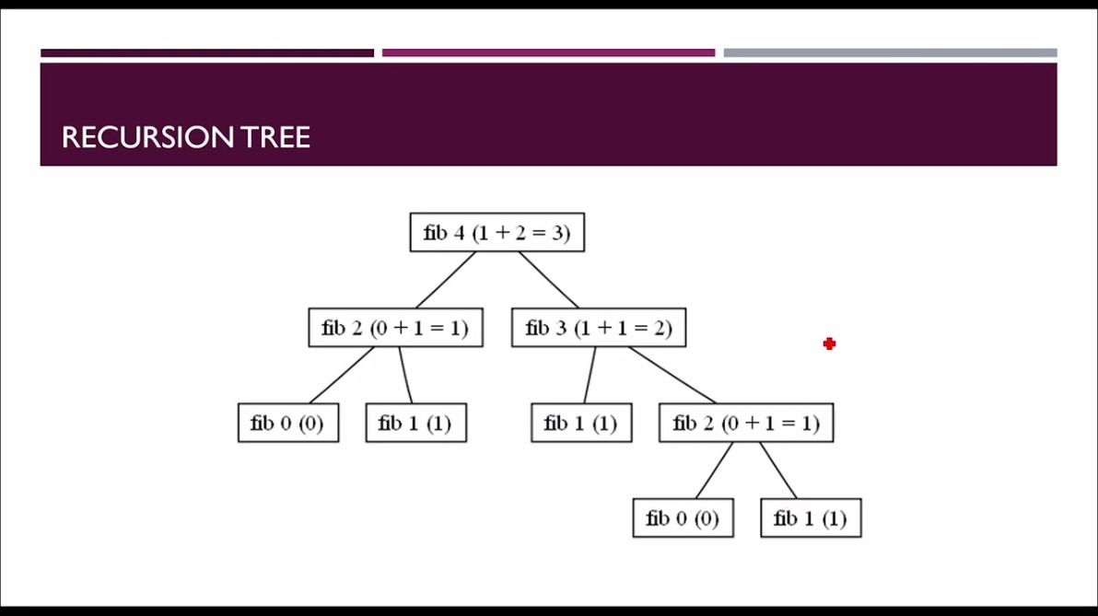

* Recursion is a good approach when it comes to problem solving.
* However, programmer needs to evaluate the need and impact of using recursive/iterative approach while solving a particular problem.
* In case of Factorial calculation, recursion saved a lot of lines of code.
* However in case of Fibonacci Series recursive approach called many functions again and again causing time waste.

So, programmer must have to evaluate which approach he/she should use to solve any particular problem.